**1.Create a class Box that uses a parameterized method to initialize the dimensions of a box.(dimensions are width, height, depth of double type). The class should have a method that can return volume. Obtain an object and print the corresponding volume in main() function.**

public class Box {

double h, w, d;

Box(double width,double height,double depth) {

h = height;

w = width;

d = depth;

}

double volume() {

double v;

v = h * w * d;

return v;

}

public static void main(String[] args) {

Box b = new Box(10, 50, 15);

System.out.println(b.volume());

}

}

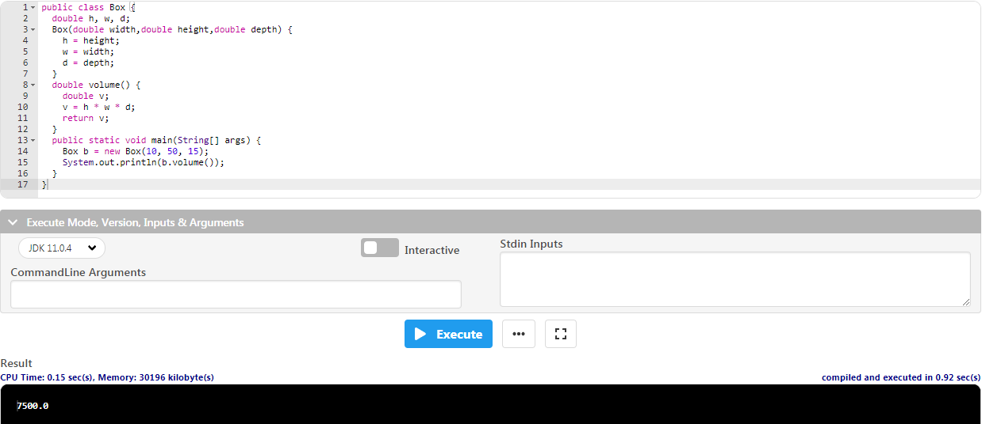

**2.** **Create a new class called “Calculator” which contains the following:**

**1. A static method called powerInt(int num1,int num2) that accepts two integers and returns num1 to the power of num2 (num1 power num2).**

**2. A static method called powerDouble(double num1,int num2) that accepts one double and one integer and returns num1 to the power of num2 (num1 power num2).**

**3. Call your method from another class without instantiating the class (i.e. call it like Calculator.powerInt(12,10) since your methods are defined to be static).**

class Main{

public static void main(String[] args) {

System.out.println(Calculator.powerInt(10, 2));

System.out.println(Calculator.powerDouble(12.0,3));

}

}

class Calculator{

static double powerInt(int num1,int num2) {

return Math.pow(num1,num2);

}

static double powerDouble(double num1,int num2) {

return Math.pow(num1,num2);

}

}

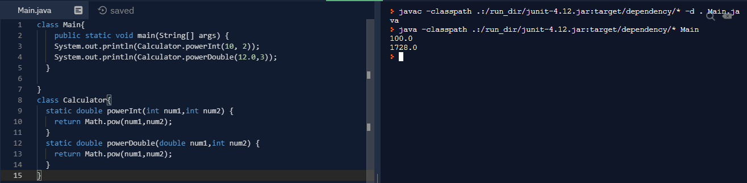

**3.** **Design a class that can be used by a health care professional to keep track of a patient’s vital statistics. Here’s what the class should do:**

**1. Construct a class called Patient**

**2. Store a String name for the patient**

**3. Store weight and height for patient as doubles**

**4. Construct a new patient using these values**

**5. Write a method called BMI which returns the patient’s BMI as a double. BMI can be calculated as BMI = ( Weight in Pounds / ( Height in inches x Height in inches ) ) x 703**

**6. Next, construct a class called “Patients” and create a main method. Create a Patient object and assign some height and weight to that object. Display the BMI of that patient.**

class Patient{

String name;

double height, weight;

Patient(double w, double h){

weight = w;

height = h;

}

double BMI(){

return ((weight / (height * height)) * 703);

}

}

public class Patients{

public static void main (String[] args){

Patient p = new Patient(60, 164);

System.out.println("The BMI: "+p.BMI());

}

}

